CSA1708-ARTIFICIAL INTELLIGENCE
LAB EXPERIMENTS
Program 12 : Python Program for Tic Tac Toe Game
Aim
To develop a Python program to implement the Tic Tac Toe game allowing two players (X and O) to make moves alternately and determine the game outcome (win or draw).
Algorithm
1. Represent the 3×3 game board as a list of 9 elements initialized with empty spaces (' ').
2. Define a function to display the current state of the board in a 3×3 grid format.
3. Define a function to check win conditions across rows, columns, and diagonals:
4. - Rows: (0,1,2), (3,4,5), (6,7,8)
5. - Columns: (0,3,6), (1,4,7), (2,5,8)
6. - Diagonals: (0,4,8), (2,4,6)
7. Define a function to check whether the board is full, indicating a draw when no empty spaces remain.
8. Initialize the starting player as 'X'.
9. Loop through the game turns:
10. a. Display the current board layout.
11. b. Accept or execute the current player's chosen move on an unoccupied cell.
12. c. Update the board with the player's symbol ('X' or 'O').
13. d. Check if the current move results in a win; if so, announce the winner and terminate.
14. e. Check if the board is completely filled; if so, declare the game a draw and terminate.
15. f. Alternate the turn to the other player ('O' after 'X', and 'X' after 'O').
16. Display the final completed board state.

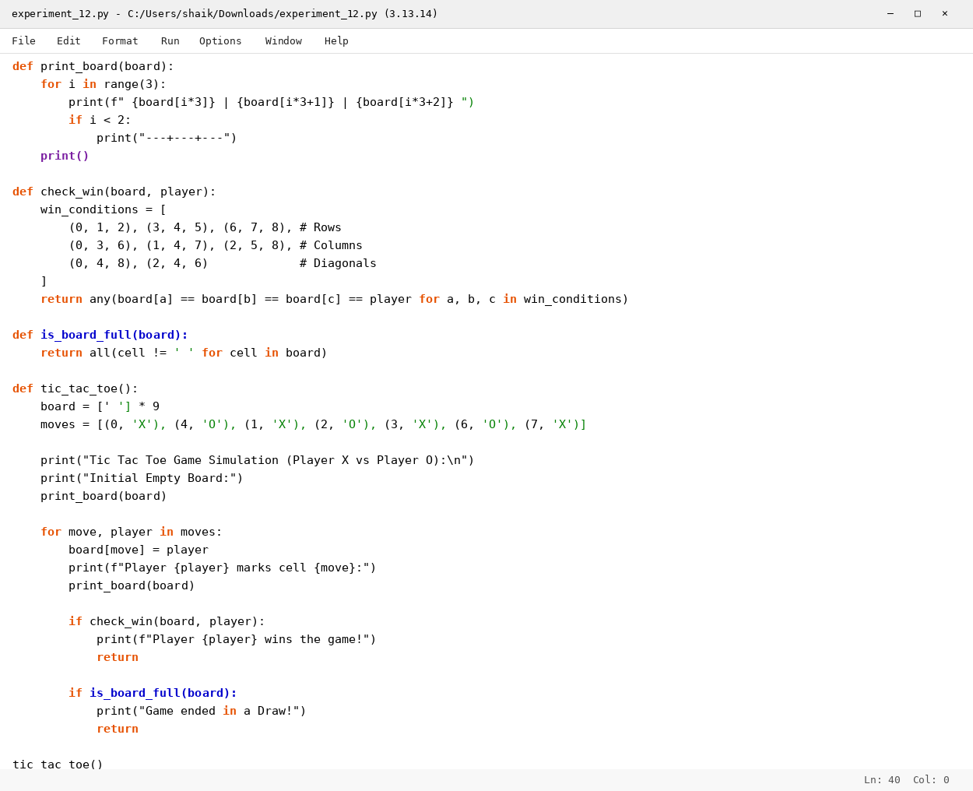

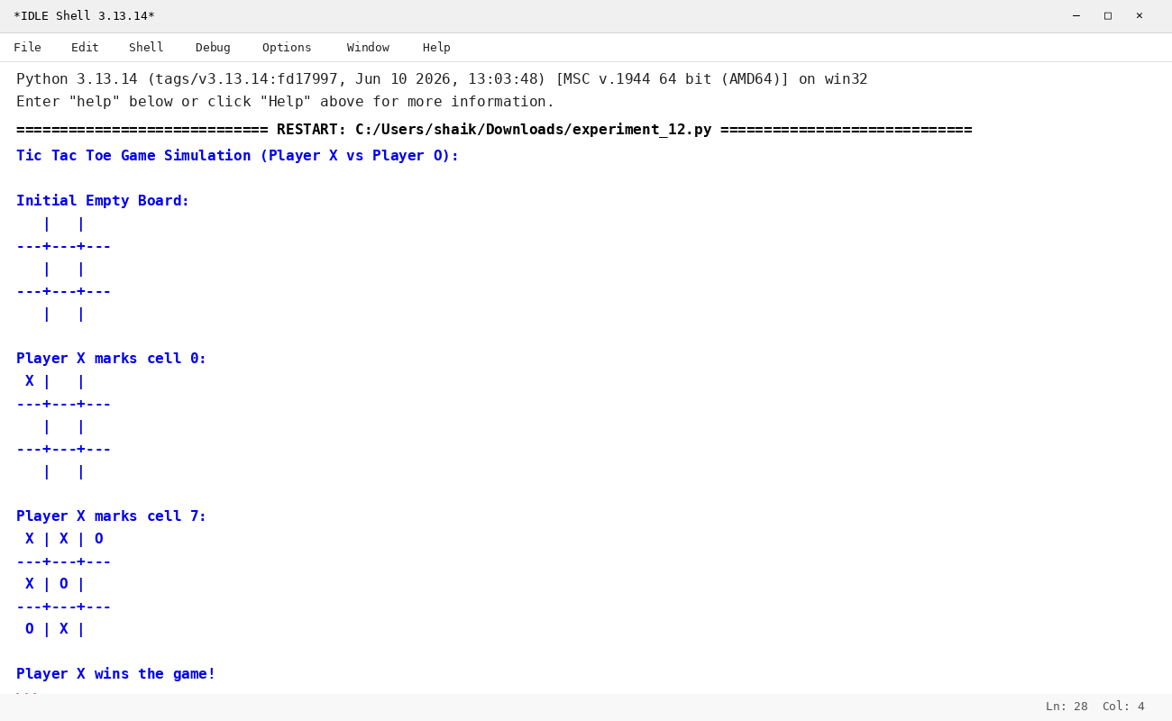

RESULT
Thus, the Tic Tac Toe game was implemented successfully using Python.

